Email Triage Assistant
David Wederstrandt
Bellevue University
DSC670 GenAI Milestone 3
Professor Neugebauer

Milestone 3 V1: Email Triage Assistant Baseline

Introduction

This document presents the baseline version (v1) of the Email Triage Assistant project developed for Microsoft Copilot. The goal is to build an intelligent agent that classifies incoming Outlook emails and provides concise, actionable summaries.
The v1 agent implements core triage functionality: it categorizes emails as High, Medium, or Low priority, generates concise summaries, and restricts actions to Outlook workflows only, explicitly excluding Teams and SharePoint.
This baseline approach provides fast, directional triage behavior suitable for initial validation and sets the foundation for future iterations.

Source Email Examples

The agent was tested against three representative email types to demonstrate its behavior across different scenarios:
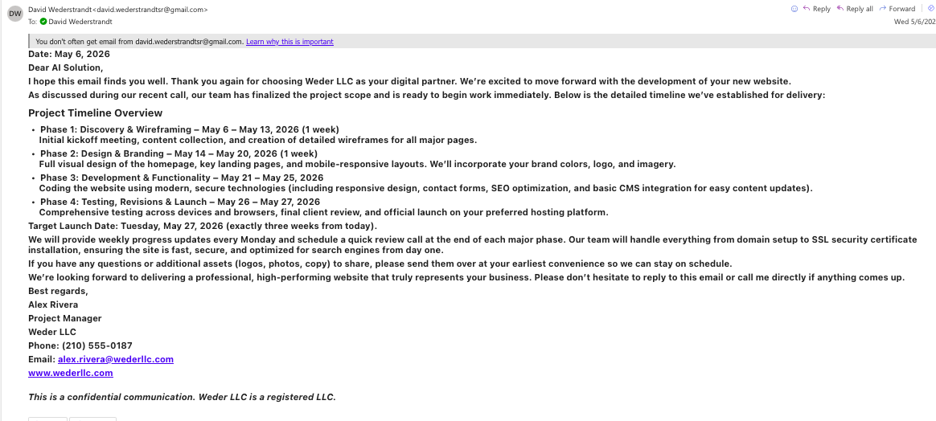
Figure 1. Weder LLC Project Coordination Email:

A detailed project timeline email from a web development partner outlining phases, deliverables, and deadlines. This test case demonstrates how the v1 agent handles complex project-related communications.
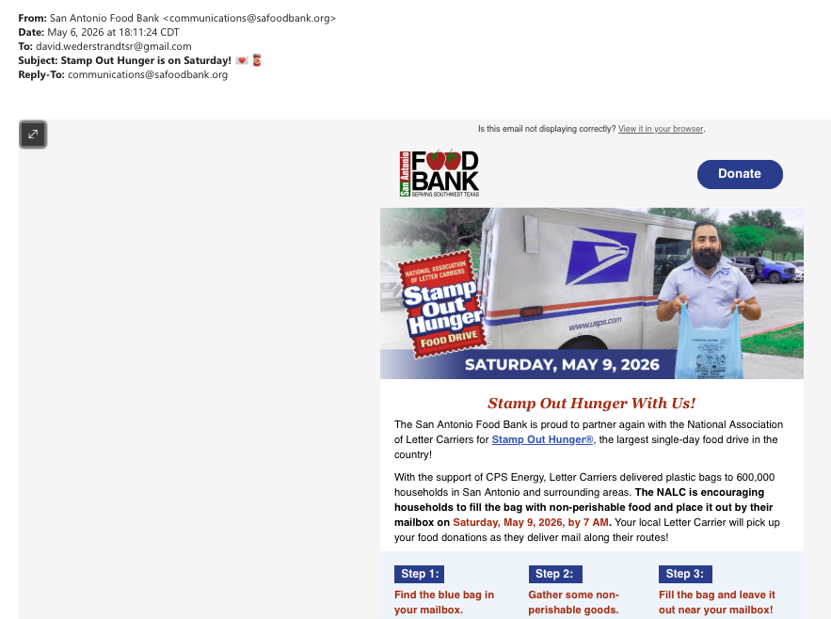
Figure 2. Food Bank Stamp Out Hunger Reminder:

An informational email about a community food bank participation event. This example shows the agent's ability to triage optional community engagement requests.
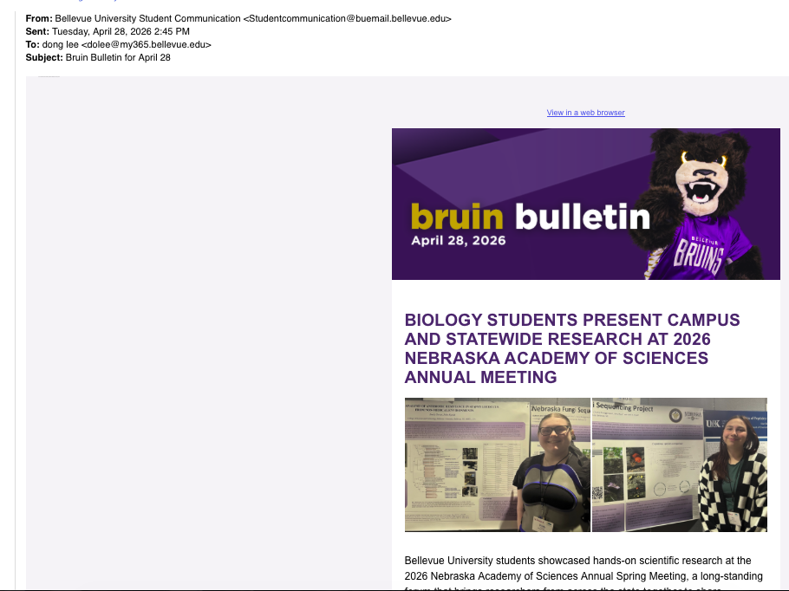
Figure 3. Bruin Bulletin Newsletter:
A university bulletin with campus announcements and events. This represents the newsletter category of emails that the agent must correctly classify as informational.

Agent V1: Email Priority Assistant

The v1 agent applies simple, fast triage logic to classify incoming emails. It assigns a priority label (High, Medium, or Low) and creates a summary without returning JSON or structured machine output.

Key constraints include Outlook-only actions and the Unclassified fallback for low-confidence outcomes. This baseline approach focuses on speed and clarity, making it easy to validate the core triage logic before adding complexity.

Outlook Summary Output (V1)

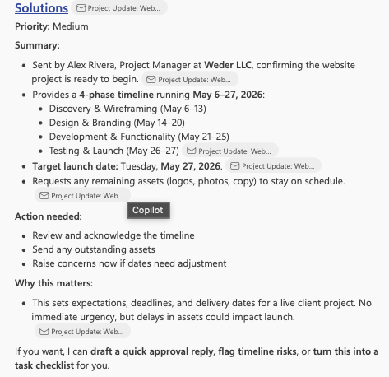
Figure 4. Outlook Summary V1:

Figure 4 shows the baseline triage output with priority assignment, summary, and next-step recommendations. The output demonstrates the core v1 functionality in action.

The v1 output provides directional priority classification with a concise narrative summary. The structure is readable and useful for quick inbox triage, though the detail level and standardization are less refined than later iterations.

Food Bank Email Summary (V1)

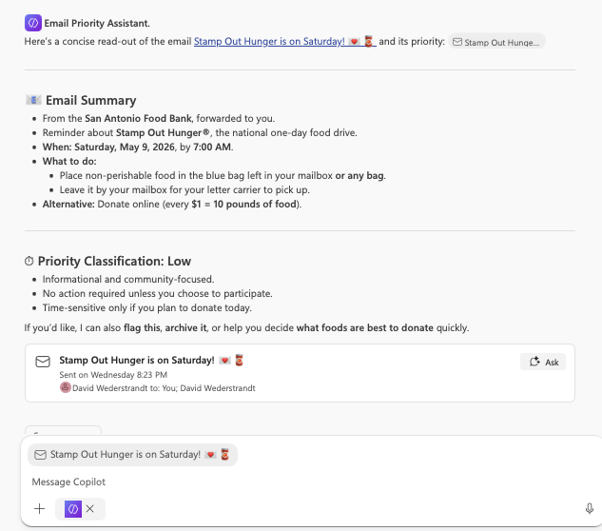
Figure 5. Food Bank Summary V1:

Demonstrates v1 triage for informational/optional content. The agent correctly assigns a low priority to this type of email.

For optional, informational emails like the Food Bank reminder, v1 correctly assigns Low priority. The summary captures the event context with minimal but sufficient detail for quick decision-making.

Bruin Newsletter Summary (V1)
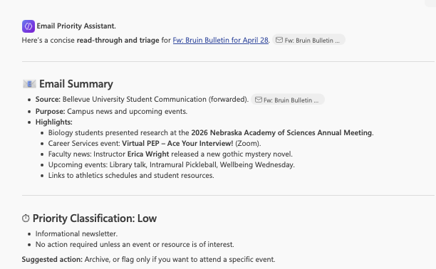
Figure 6. Bruin Newsletter Summary V1:

Figure 6 shows v1 treatment of newsletter-style content. The classification and summary capture the appropriate low-priority categorization for this email type.
Newsletter content is correctly treated as Low priority. The v1 agent concisely highlights key items, though the output structure lacks the standardization and depth that future versions provide.

Conclusion

The v1 agent successfully establishes baseline email triage functionality within Outlook workflows. Classification logic is sound, and the output is readable and actionable for quick inbox decisions.

Testing against three representative email types—a project coordination email, a community event reminder, and a university newsletter—demonstrates consistent and correct priority assignment. The Weder LLC project email was appropriately categorized as requiring action coordination, while both the food bank reminder and Bruin bulletin were correctly identified as low-priority informational content.

The core v1 design successfully implements the fundamental triage workflow: receiving an email, classifying its priority level, generating a concise summary, and suggesting next steps. By restricting actions to Outlook and excluding Teams and SharePoint, the agent maintains focus on a single, well-defined channel for email delivery and collaboration.

However, the v1 iteration reveals important limitations that guide future development. The output structure varies slightly across email types, making it harder to apply consistent patterns across a large inbox. The depth of reasoning provided for priority assignment is minimal, and the reply draft suggestions are basic. Confidence handling is not explicitly tracked, and there is no formal fallback mechanism for ambiguous or low-signal emails.

These gaps are not failures but rather natural starting points for refinement. The v1 baseline provides a solid foundation for more sophisticated triage capabilities. Future iterations will add structured output sections, explicit confidence tracking, richer decision rationales, and more professional reply guidance.

Next Steps

- Expand the instruction set to include explicit classification rules and confidence policy.
- Introduce structured output sections (Priority, Confidence, Summary, Next Steps, Reply Draft, Reason for Priority).
- Add guardrails to prevent the fabrication of facts and clarify how to handle uncertain or missing context.
- Validate improved consistency and depth against the same test email set.

